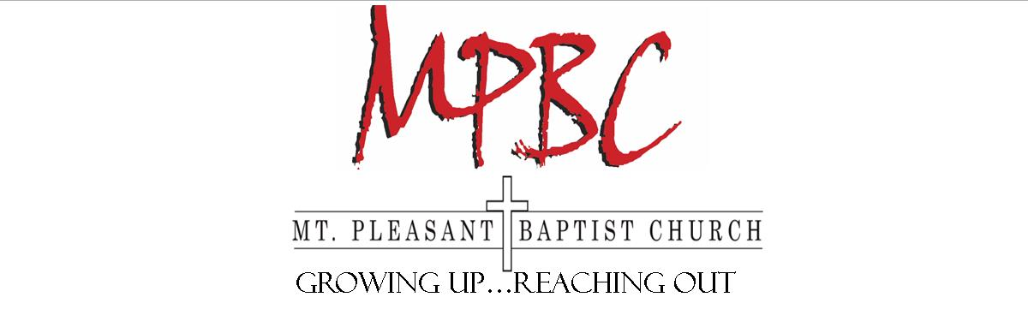
Growing Up…Reaching Out

To Whom It May Concern:
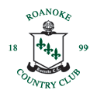
We are currently planning for our 2017 Mount Pleasant Golf Tournament at Hunting Hills Country Club on June 3. We are working hard to make this event successful by offering a top-quality atmosphere along with great prizes for our winners. With this, we hope to raise the funds necessary to help support our Student Ministry Missions Team at Mount Pleasant Baptist Church.

We would like to ask for your support with any prize donations or advertising to help draw golfers to our event. We are also offering advertising through hole sponsorship at $100 per hole. If you are interested in hole sponsorship, we will gladly advertise for your business or organization at our event and on our website. All support comes with the knowledge that you are investing into the lives of people we will be able to serve in the future. If you have any questions, please feel free to call Bobby Vann at 540-685-0804. We thank you for your time and support.

Sincerely,
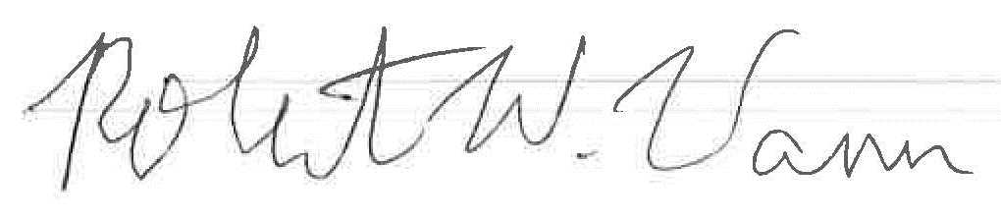

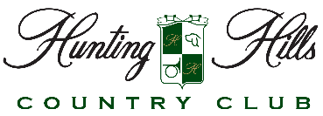
Bobby Vann,
Student Minister
Mount Pleasant Baptist Church

3000 Pitzer Road ~ Roanoke, VA 24014 ~ 540-427-5494

