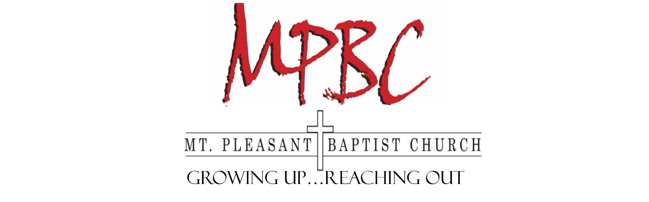
Dear family and friends,

I have something very important to share with you. I have been given the opportunity to serve this upcoming summer as part of MPBC’s mission team to Liberty Texas in July 2018. While meeting the needs of those we will be serving in Liberty, I know I will be challenged physically, socially and spiritually – it will be a life-changing experience for me.

Our high school mission team will be serving with the BGAV and FBC Liberty in Texas to help with the rebuilding process in the wake of Hurricane Harvey. During this week I will have multiple opportunities to serve people and leave a lifelong impact on those I am able to serve.

In order for this trip to be possible, I am responsible for raising approximately $600-700 to be able to travel to Liberty, Texas and serve the people there. Our team’s hope is to raise the majority of this through sponsorships and fundraisers.

If you would be willing to help sponsor me financially, it would be greatly appreciated. Any donations will be greatly appreciated. Please make checks payable to “Mt Pleasant Baptist Church” and simply write my name in the memo. Please also send your name, address, phone number, and your relationship to me in the envelope. All donations toward my deposit are asked to be sent by June 1st. Your support will play a vital role in this opportunity. All donations are tax-exempt.

Please be in prayer for us as we will be working hard to prepare for this trip. Thanks again for your support!

In Christ,

*Unless you are related, money received from members of MPBC will be split among all mission trip participants.
Mount Pleasant Baptist Church ~ 3000 Pitzer Road ~ Roanoke, VA 24014 ~ 540-427-5494

